LFP Analysis Pipeline
Documentation for Neural Signal Analysis and Anxiety State Detection
This document provides comprehensive guidance for using the LFP (Local Field Potential) analysis pipeline developed for the Provenza Lab. The system is designed to analyze neural signals from DBS (Deep Brain Stimulation) patients with OCD and investigate relationships between frequency band power and anxiety levels measured through SUDS (Subjective Units of Distress Scale).

Table of Contents
- Project Structure
- Dependencies and Setup
- Core Classes
- Analysis Workflow
- Plotting Functions
- Machine Learning Pipeline

1. Project Structure
The project is organized into modular components for maintainability and reusability:
File | Description
classes/__init__.py | Package initialization, exports LFPData and BandAnalysis classes
classes/LFPData.py | Core class for loading, preprocessing, and managing LFP data
classes/BandAnalysis.py | Frequency band power analysis (Theta, Alpha, Beta)
plot_functions.py | Visualization functions for LFP signals and analysis results
analysis.ipynb | Main Jupyter notebook demonstrating the complete analysis workflow

2. Dependencies and Setup

Required Libraries
- numpy - Numerical computing
- pandas - Data manipulation and analysis
- scipy - Signal processing (scipy.signal)
- matplotlib - Static visualizations
- seaborn - Statistical visualizations
- plotly - Interactive visualizations
- scikit-learn - Machine learning models

Installation
pip install numpy pandas scipy matplotlib seaborn plotly scikit-learn

3. Core Classes

3.1 LFPData Class
The LFPData class handles all data loading, preprocessing, and phase management operations for LFP signals.

Initialization
patient = LFPData(patient_id="AA002", session_date="2025-04-10", fs=250)
Parameters:
- patient_id (str): Unique patient identifier
- session_date (str): Recording session date
- fs (int): Sampling frequency in Hz (default: 250)

Key Methods
Method | Description
load_data(lfp_path, task_path) | Load LFP CSV and task data files. Automatically detects channel naming convention.
interpolate_nans(plot=False) | Detect and interpolate NaN values in LFP signals using linear interpolation.
demean() | Remove DC offset by subtracting the mean from each channel.
preprocess(...) | Complete preprocessing pipeline: NaN interpolation, demeaning, artifact removal, phase definition.
define_phases() | Extract experimental phases (Baseline, Exposure, Compulsions, Relief) from task markers.

3.2 BandAnalysis Class
The BandAnalysis class performs frequency band power calculations using Welch's method for spectral estimation.

Initialization
analysis = BandAnalysis(lfp_data=patient, freq_bands=None, window_sec=5.0)
Default Frequency Bands:
- Theta: 4-8 Hz
- Alpha: 8-13 Hz
- Beta: 13-30 Hz

Key Methods
Method | Description
calculate_all_bands() | Calculate power for all frequency bands continuously across the signal.
get_band_continuous(band, hemi) | Retrieve continuous power values and timestamps for a specific band and hemisphere.
get_band_by_phase(band, hemi) | Split band power data by experimental phases.
align_with_suds(band, hemi) | Align band power with SUDS scores using nearest neighbor matching.

4. Analysis Workflow
The complete analysis follows a structured workflow from data loading to machine learning classification.

Step 1: Load Data
from classes import LFPData, BandAnalysis
patient = LFPData("AA002", "2025-04-10_Session1")
patient.load_data(lfp_csv_path, task_csv_path)

Step 2: Inspect Raw Signals
Before preprocessing, visualize the raw signals to identify artifacts at the beginning and end of the recording:
plot_raw_lfp(patient, time_start=0, time_end=30) # First 30 seconds
plot_raw_lfp(patient, time_start=1230, time_end=1260) # Last 30 seconds

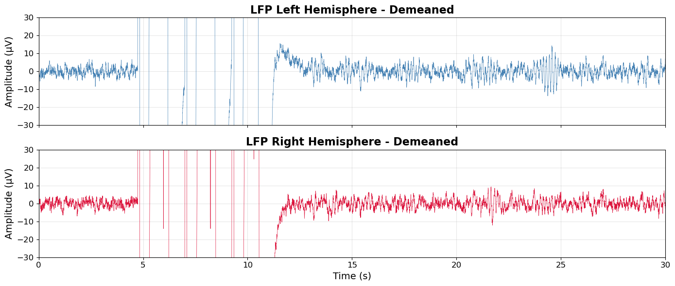

Step 3: Preprocess
Apply preprocessing with artifact exclusion based on visual inspection:
patient.preprocess(artifact_start_sec=10, artifact_end_sec=5, plot_nans=True)
This performs:
- NaN interpolation (linear)
- Mean removal (demeaning)
- Task data cleaning and SUDS extraction
- Artifact removal from signal edges
- Phase definition (Baseline, Exposure, Compulsions, Relief)

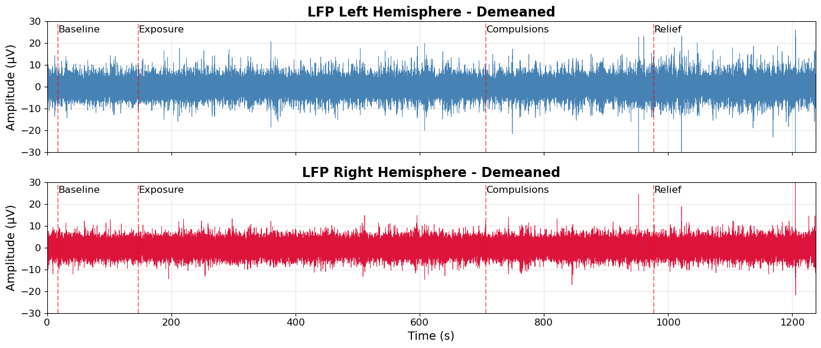

Step 4: Band Power Analysis
analysis = BandAnalysis(patient, window_sec=2.0)
analysis.calculate_all_bands()

# align with suds
powers, suds_aligned = analysis.align_with_suds('Theta', 'left')
# timeseries plots
plot_band_suds_timeseries(analysis, 'Theta')

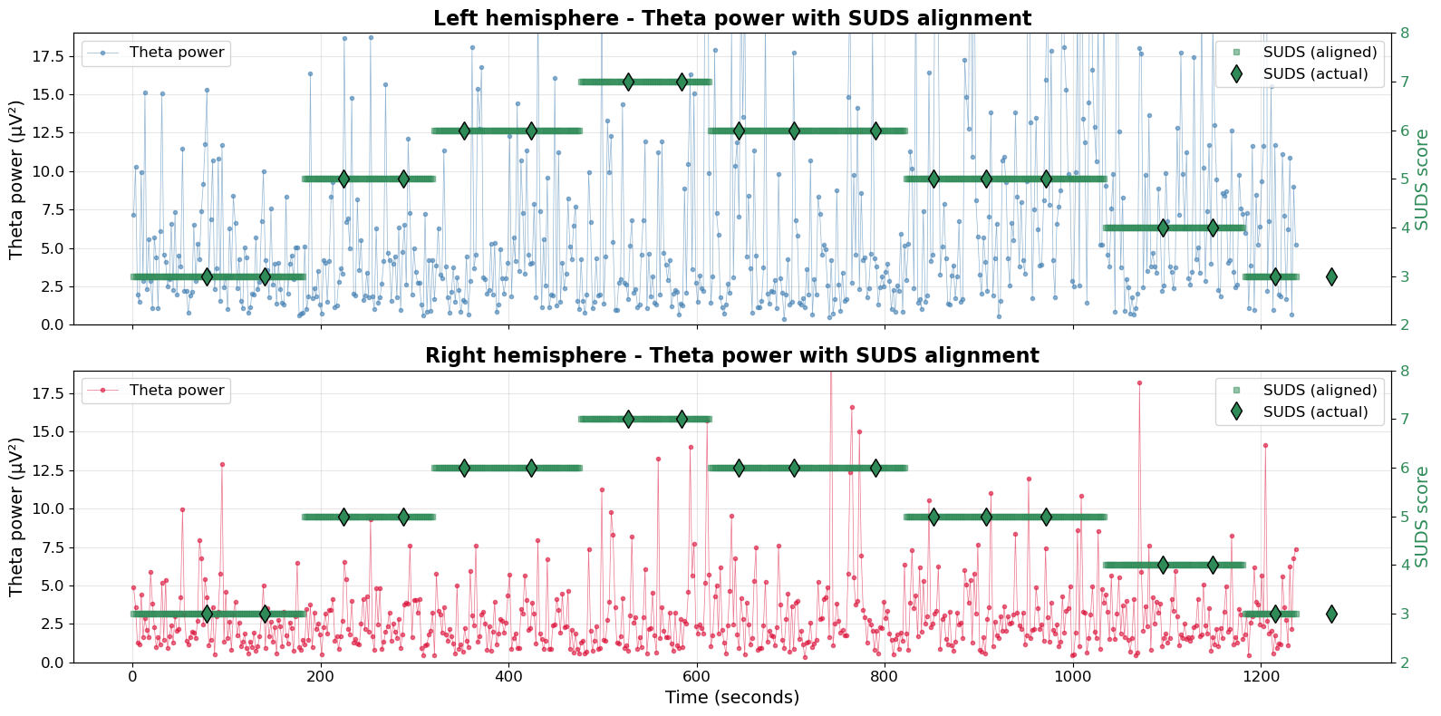

Step 5: Create Analysis DataFrame
powers, suds_aligned = analysis.align_with_suds('Theta', 'left')
df = pd.DataFrame({
'time': analysis.results['Theta']['times'],
'Theta_left': analysis.results['Theta']['left'],
# ... add other bands
})

5. Plotting Functions
The plot_functions.py module provides comprehensive visualization tools for LFP analysis.
Function | Description
plot_raw_lfp(patient, ...) | Plot raw LFP signals with optional time window and phase markers.
plot_spectrograms(patient, ...) | Generate time-frequency spectrograms for both hemispheres.
plot_band_continuous(...) | Visualize band power over time with experimental phase highlighting.
plot_suds_correlation(...) | Scatter plots with Pearson/Spearman correlations between band power and SUDS.
plot_band_distributions(...) | Compare band power distributions across experimental phases.
plot_suds_and_spectrograms(...) | Interactive Plotly visualization combining SUDS timeline with spectrograms.
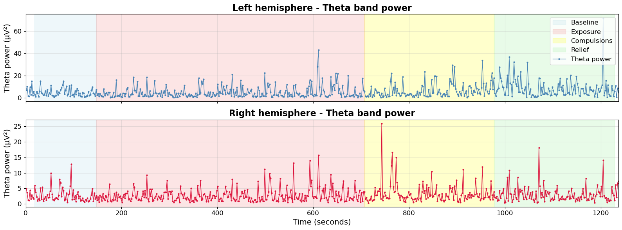
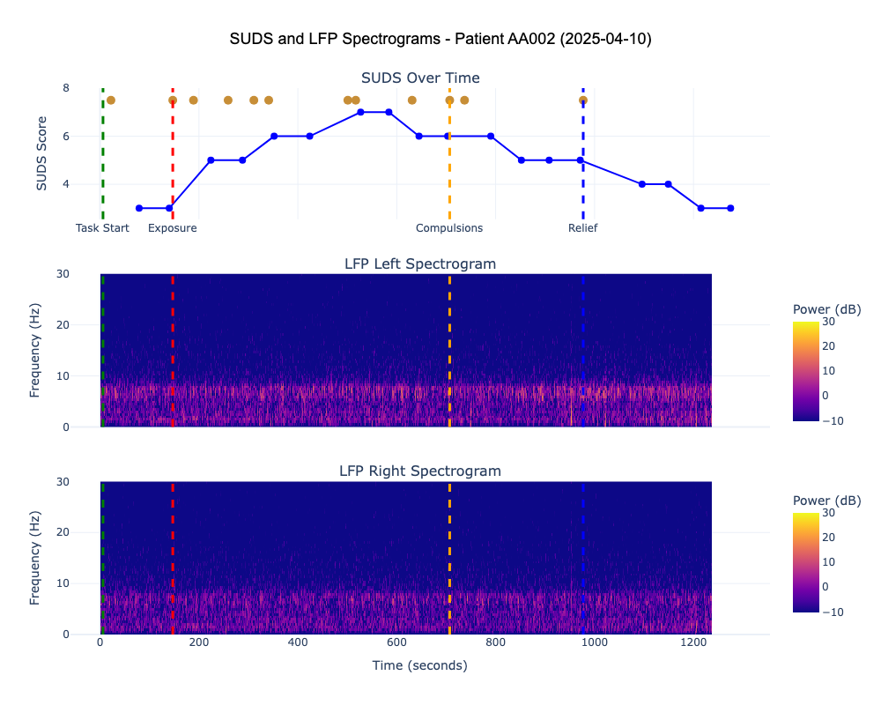
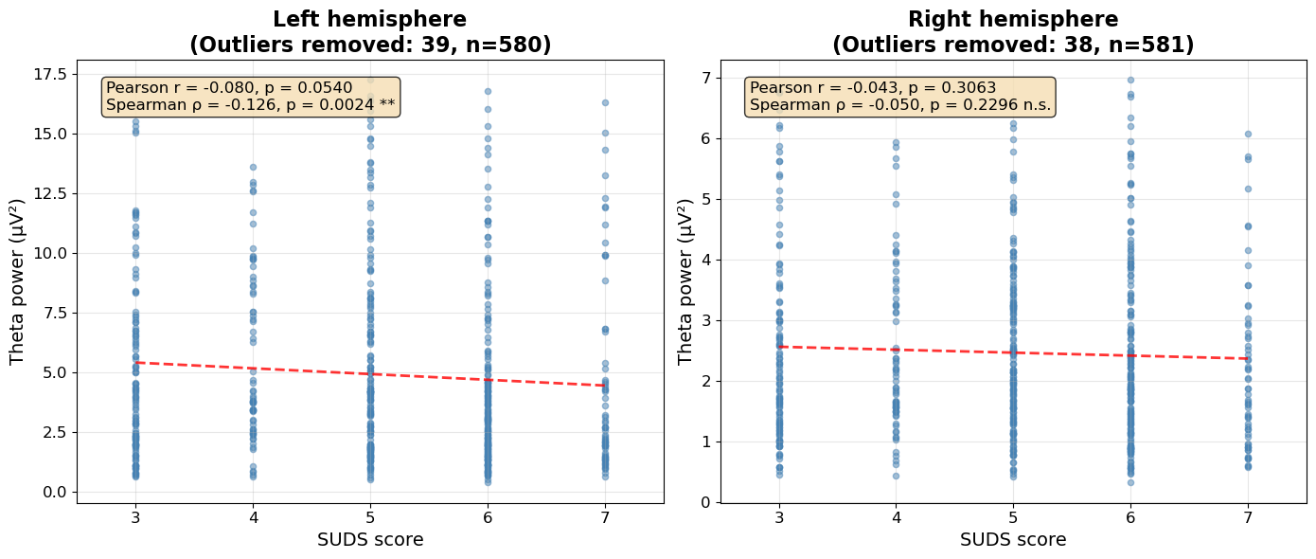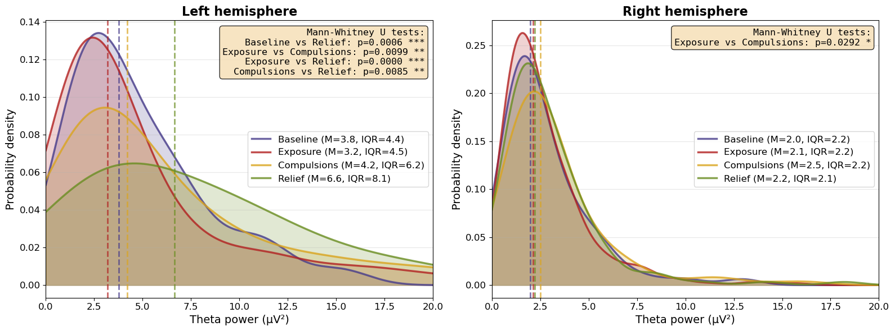

6. Machine Learning Pipeline
The notebook implements two classification approaches to detect stress/anxiety states from neural features.

6.1 Model 1: Anxiety Detection (SUDS-based)
Binary classification of High vs Low anxiety based on median SUDS score.
median_suds = df['suds'].median()
df['anxiety_binary'] = (df['suds'] >= median_suds).astype(int)

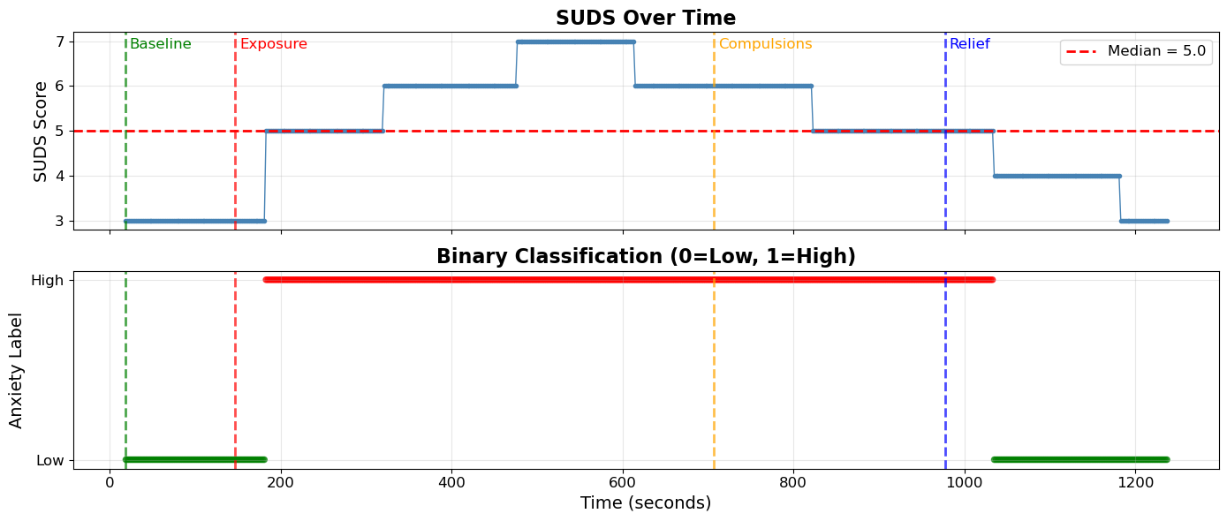

6.2 Model 2: Stress Detection (Phase-based)
Binary classification of Stress (Exposure + Compulsions) vs No Stress (Baseline + Relief) based on experimental phases.
stress_phases = ['Exposure', 'Compulsions']
df['stress_binary'] = df['Phase'].isin(stress_phases).astype(int)

6.3 Key Results
Model | Target | Accuracy | Key Finding
Logistic Regression | Anxiety (SUDS) | 48.4% | Below chance level
Random Forest | Anxiety (SUDS) | 66.7% | Biased toward majority class
Random Forest (balanced) | Stress (Phase) | 61.5% | Above chance, honest performance

6.4 Feature Importance
Analysis revealed that Theta_left is the most predictive feature (importance = 0.22), followed by Theta_right (0.17). This supports left-lateralized effects observed in exploratory analysis. 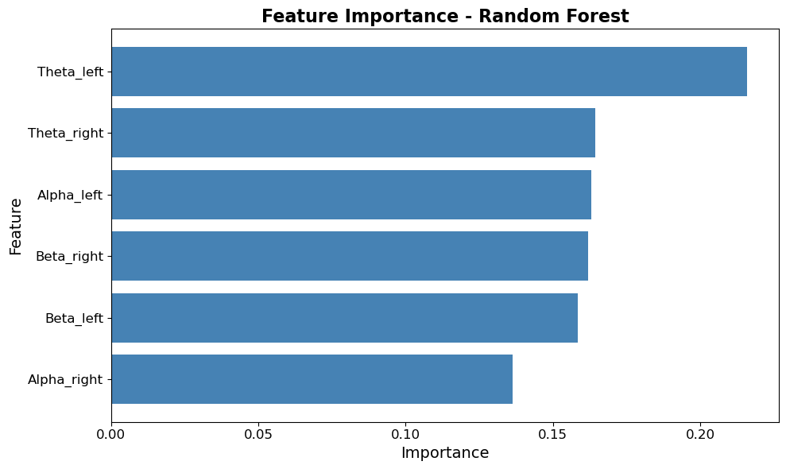

7. Key Conclusions
- SUDS-based anxiety detection fails with band power features alone, likely due to weak correlations and limited SUDS range.
- Phase-based stress detection shows modest improvement (61.5% vs 50% chance), indicating clearer neural signatures between experimental conditions.
- Left-hemisphere Theta activity is the most reliable neural marker for distinguishing stress states.
- Future work could explore band ratios, asymmetry indices, or temporal dynamics for improved classification.

8. Data Requirements

LFP Data CSV
The system automatically detects one of the following channel naming patterns:
- TD_Aic_ONE_THREE_LEFT / TD_Aic_ONE_THREE_RIGHT
- TD_Aic_ZERO_TWO_LEFT / TD_Aic_ZERO_TWO_RIGHT
- TD_Other_ZERO_TWO_LEFT / TD_Other_ZERO_TWO_RIGHT
- TD_Other_ONE_THREE_LEFT / TD_Other_ONE_THREE_RIGHT

Task Data CSV
Required columns and entries:
- Timer column with format MM:SS:ms
- Event column containing 'SUDS' and 'Note' entries
- Entry column with phase markers: 'Task Start', 'exposure', 'compulsions', 'relief'

